 |  |  | Generic Lesson Planning Template
Year Level/s: 3 Date: KLA/s: Geography Duration: 40 minutes
Syllabus Outcomes/Essential Learnings or Skills (What is the broad educational goal in terms of the syllabus or curriculum?)
Australian Curriculum: Geography [Draft version]
Environment: the use of natural resources and disposal of waste effects the environment
- Elaboration: Investigating the environmental effects of consumption for example, the waste that is generated by school, homes daily travel and holidays and where this ends up
- Elaboration: Experimenting with ways to reduce their effects on the environment, for example sorting rubbish into what could be recycled or composted
Lesson Objective: What specific part of this broad goal does this lesson aim to develop? A good objective must indicate “Given what, Do what, How well?”
Given that the class has a focus on sustainability and the environment, students will consider the effects of consumption, categorise waste, research how waste is disposed of at home and school and complete a weekly audit of the recyclables they have at home and complete a graph to show the results.
Know and Do: By the end of the lesson what knowledge (content and understandings) and skills (processes) do students need to develop?
Students need to know ...  - Many human activities have a harmful effect on the environment  - Choices we make about how we live can reduce our consumption of resources |  |  |  | Students need to be able to ...  - Classify waste into categories  - Investigate waste using books, the internet and information sheets  - Collate information into a graph
Evaluation/ Monitoring and Assessment:
Prior Knowledge: (How will I find out what the students know and/or remember?):  Students have real world experience disposing of waste |  | Formative Assessment: (How will I monitor student understanding along the way?):  Monitor student contributions/clarify misconceptions and ask ‘why’ |  |  | Summative Assessment: (How will I provide concrete evidence of student learning?):  - Sort waste into categories, (reduce, reuse, recycle) and defend their choice  - Able to explain one waste disposal method  - Complete a graph that accurately depicts their own waste habits.
Resources  needed: | IWB, You tube clip http://www.youtube.com/watch?v=L3HUiTi4xv8&feature=youtu.be, books on waste/pollution, waste tips sheet, rubbish interactive site from http://www.brysoneducation.org/age_8_11/sort_it_out_waste/rubbish.asp,  Google earth, waste or recycle IWB activity http://www.prometheanplanet.com/en/Resources/Item/36720/waste-or-recycle#.UG_aOpish8F actual rubbish+ containers for sorting, paper pencils , top 10 waste tips sheet, waste worksheet

Teaching Strategies and Learning Steps
What to say Organisation/Resources Individualising learning
Introduction - key learnings and how they will be achieved (Consider strategies, relevance, individual/group work, clarify student understandings of task, student voice, student choice etc.)
Time Allocation: 10 minutes  Watch you tube video (contains questions/information to activate prior knowledge)  Discuss our everyday practices; can students answer the questions posed in the video  Look at the sort it out website on the IWB- to see what happens to waste when it reaches the dump | What key messages will I convey?  That humans have a harmful effect on the environment, but that we can take steps to lessen this through reducing the amount of our waste | How will I organise learning activities and utilise resources? ......  Have websites ready to go, download Google earth before lesson | How can I make adjustments to meet individual student needs?  Allow wait time for thinking, provide resource books for students if they finish early
Lesson Body - step by step outline of learning experience sequence (Consider HOTS tasks, monitoring understandings, provision and use of resources, general student responsibilities etc.)
Time Allocation:20 minutes  On IWB, look up the dumps listed in the resources section. Compare size of dump to houses/roads/landmarks. Consider the closeness of the rivers to two of them  Ask-----------------------------------------------→  Read statistics  Ask students (in table groups) to choose one item that could be reduced, reused, or recycled, and explain their choice to the class  Ask------------------------------------------------→  Activity sheet-Students make a list of things they throw away regularly at home | What questions will I ask?  How long do students expect it will take for these dumps to be filled?  What kind of waste do students think is likely to be in these dumps?  How much of this rubbish needs to go into the bin; how much could we avoid putting into landfill? | How will I handle the transitions between activities?  Ask students to get the things they will need before the lesson begins, and pack away when they are finished | How will I know if students are achieving the learning objective/s?  Through discussion and in the sorting activity, can students sort the rubbish into appropriate categories?
Conclusion - reviewing learning/ Summarising/Articulating where to next (Strategies to capture learning that occurred and move thinking forward.)
Time Allocation: 10 minutes  Open graph on IWB  Ask students for the information from their Activity sheet; input it into the graph.  Reflect on the information. Could we make changes at home to reduce our waste? Do students think their own practices affect the wider environment? | How will I help students to synthesise learnings?  Refer to You Tube movie from the beginning of the lesson during later parts, discuss the rubbish we sorted- is this similar to the sorts of things on student lists? | What plans are in place for those who finish early?  Students can read though books on waste/pollution  Colour in their ‘top 10 waste tips sheet’ | What about those who need more time?  Graph can be completed on the IWB using the information students had time to
Reflection and Adjustments
Prac Course: Prac site: Week: Lesson No: Unit/ Topic Area:

Did students learn what they were supposed to? | How could this lesson be improved for next time?
(Self-evaluation of learning experience outcomes)  Deconstruct: The students were easily able to connect the objectives of the lesson to their own lives and had a very energetic discussion about their own and others practices. Students were very good at choosing an item from the rubbish that fit the categories of reduce, reuse and recycle and engaged in higher order thinking, which is reflected in the mentor teacher, Sarah McCarthy’s lesson feedback.  Confront: There were however some significant wait time issues, when groups were deciding on their object to choose, the others were not adequately catered for, and there were also issues gaining and maintaining students attention when instruction was given  Theorise: According to Tobin and Capie (2007) among the variables that contribute to academic learning is wait time, which disrupts on task behaviour and can disrupt learning experiences.  Think otherwise: Because of this and other research which supports the importance of on-task behaviour, it is vital for teachers to adequately plan for times within lessons that may involve significant waiting, however as this was the first lesson taught on the first day of the first primary classroom prac, there is adequate scope to learn from and extend future learning experiences | (If I was to teach this lesson again what would I change and why?)  I would have gone through the behaviour expectations before lesson, and explained more clearly what was expected in each stage of the lesson, as well as used more creative and engaging behaviour cues when students became off-track and noisy. I would also be more aware of timing, so The whole of the lesson could be completed within the allocated time frame.
What’s next? | How were authoritative pedagogies supported?
(Points to inform subsequent lesson)  Continue learning about waste and its effects on the environment and animal/plant life, as well as how we are personally effected | (e.g. Productive Pedagogies, Bloom’s Taxonomies, Habits of Mind)  Blooms:  Comprehend: Understand  Apply: extend  Analyse: Recognize Classify Discriminate  Gardner:  Visual  kinesthetic  auditory
References to remember:

Tobin, K. & Capie, W. (2007). The influence of wait‐time on classroom learning. European Journal of Science Education. 5(1). 35-48
Suggestions/Comments from others: written mentor feedback upon conclusion of lesson
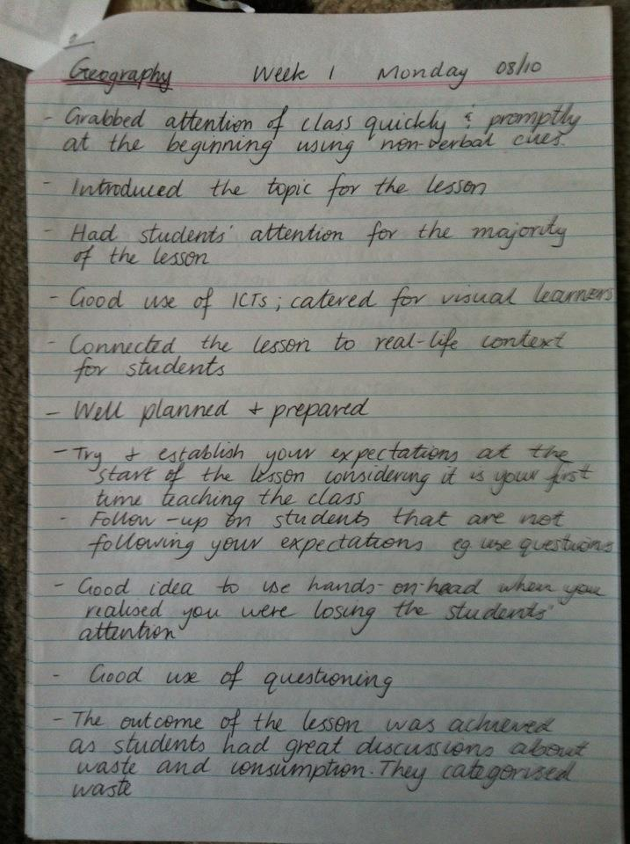
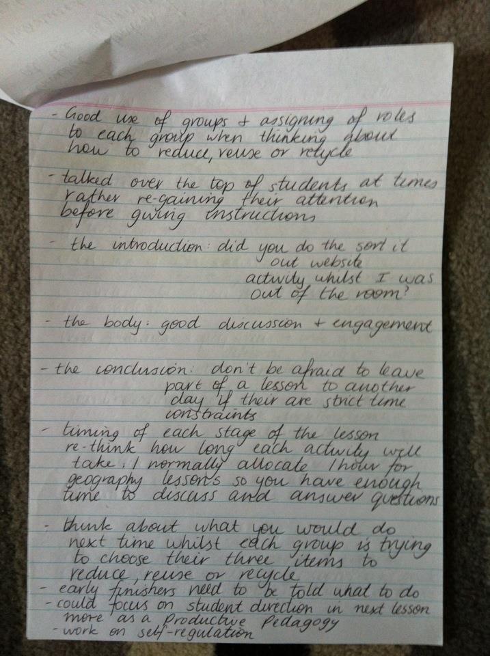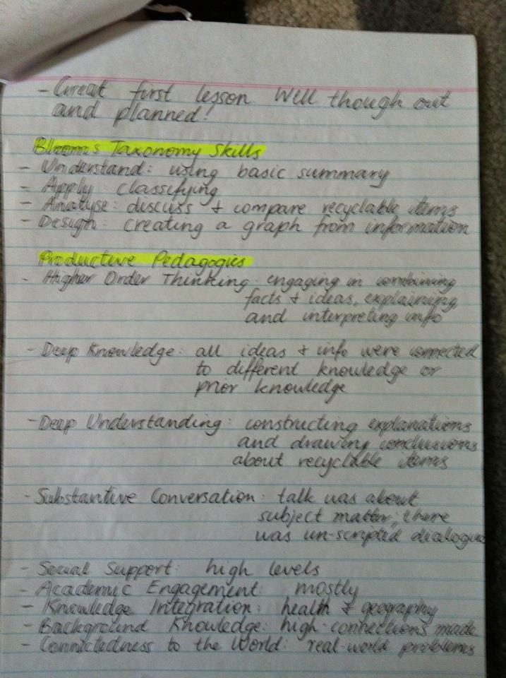

Notes:
- Puente Hills Landfill will be full and close on 2013 -It currently takes 822 trucks of trash a day
- Newton County Landfill Partnership has closed phase two, and covered it with a layer of dirt and cement to keep the smell down, phase three is open now
- Johnson County Landfill Shawnee will be open till 2043

