Great Gardening Gurus

My Great Gardening Gurus of Year 2,

I have set out a task for you to design an environmentally friendly and sustainable school vegetable garden that we will use to grow a range of fresh produce that can be harvested and used within the school community. The vegetable garden will be built later this year.

You will need to use a range knowledge and skills throughout the design and planning process to ensure that this vegetable garden will be the best possible vegetable garden we can develop, providing the best produce for our tuck-shop.

You must work through the tasks and activities below to complete the tasks by the timeframes set out by me. We will work through one task per lesson. If you have completed a task before the rest of the class you may go to the ‘Fast Finishers Corner’ and work silently.

Before you begin, please print a copy of this document as you will need to fill in your answers to some questions, both writing and drawing, and there may even be some colouring in. You will need to use this electronic copy to access the games.

If you require help at any point with this project, please ask myself or a teacher aide.

Kind regards,

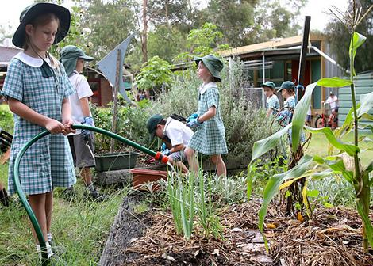
Miss Smyth

Background Information for Teachers
Task 1:
Have you grown vegetables before? Click the picture below to watch the short video about vegetable gardens. There is some very important information in this video that you will need for the tasks so listen carefully! Once you have finished watching the video you may colour in the vegetables below.

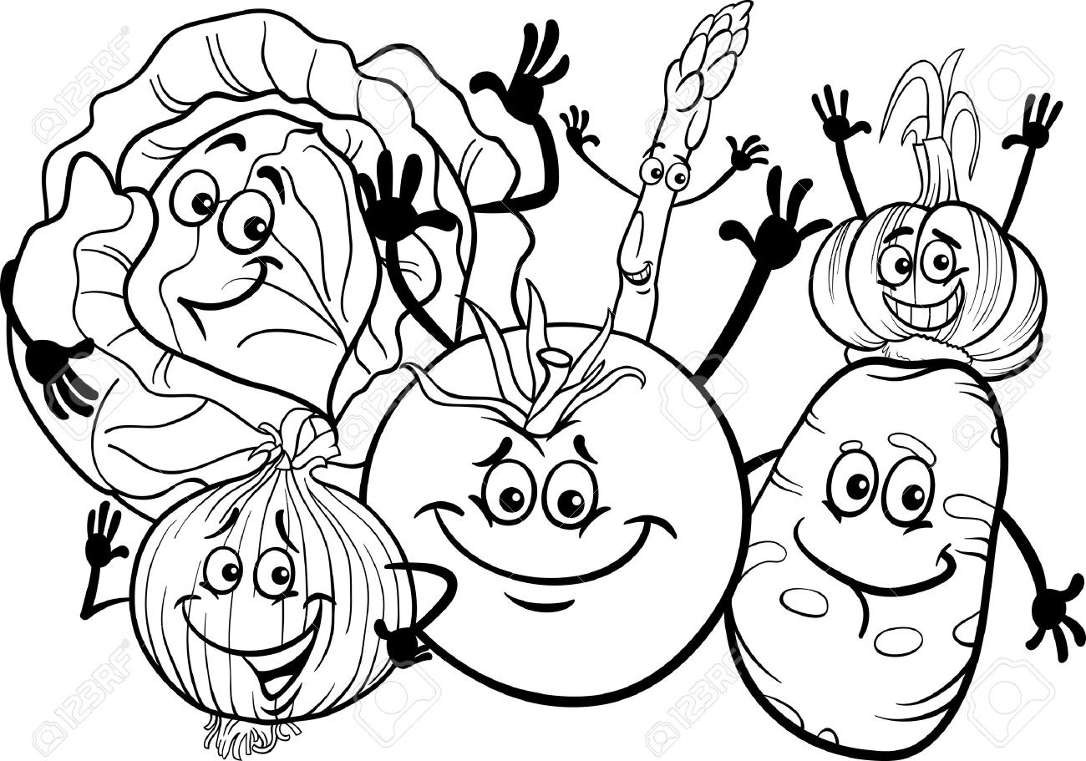
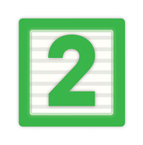
TASK 2:
The map below shows the school grounds at present. You must decide where on the school grounds will be the best place for us to build the vegetable garden. It is important that we have lots of space to grow the vegetables.

Remember, the vegetable garden will need to be somewhere that is easy for us to access so we can look after the produce.
Option B
A BLOCK
C BLOCK
B BLOCK
D BLOCK
Prep
Year 3
Year 2

Year 1
Year 6
Year 4
Year 5
Admin
Senior
Sports Oval
Junior
Sports Oval
Play
ground
Play
ground
Trees
(Out of bounds)

Eating area
Years 4,5,6
Tuckshop
Years 1,2,3

Option A
Option: ____

Why did you choose this option?

___________________________________________________________________________

___________________________________________________________________________

___________________________________________________________________________

___________________________________________________________________________

___________________________________________________________________________

___________________________________________________________________________

___________________________________________________________________________

TASK 3:
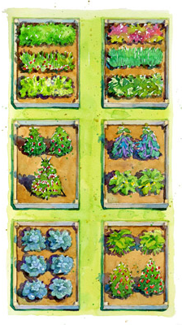
You now need to design the size and shape of the vegetable garden. You may have more than one garden in the area however it must be a user friendly design that makes it easy to access the plants and does not waste space. Some examples of design options have been provided for you. Use the box below to create your vegetable garden.
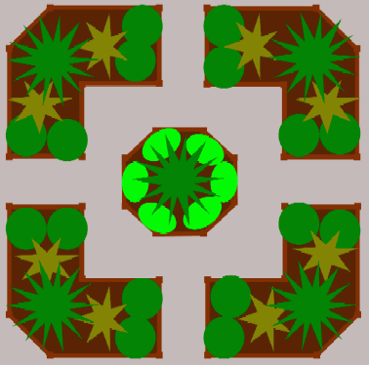

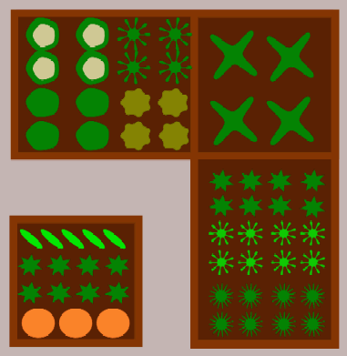

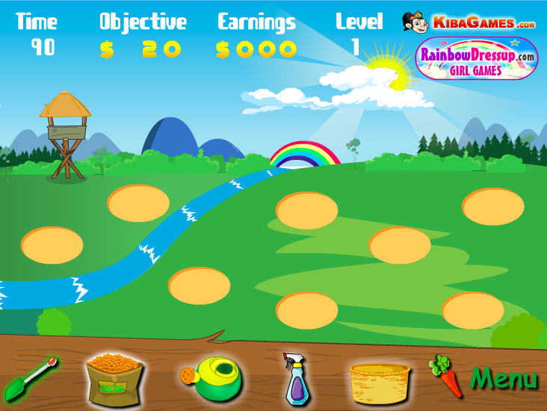
TASK 4:
This game will give you an idea about the products we will need to purchase for our own vegetable garden.

Click on the image to play Vegetable Garden.

Q. Finish the sentences below to complete the list of items we will need to grow vegetable crops from seed to harvest. One has been done for you.

First I used a _________ to dig the holes.

Then I planted some ___________.

Next I used a _______ to water the seeds. I used the ______ again to help the seedlings grow into a plant and again to help the plant grow even stronger.

I used the ________ again to dig up any weeds in my vegetable garden.

After that, I used a spray bottle to spray my plants in case there were any bugs on them.

Then I watered my plants two more times to help them grow and I harvested the vegetables by picking them and putting them into a _________.

Shopping List:
- ______________
- ______________
- ______________
- spray bottle
- ______________

Task 5:
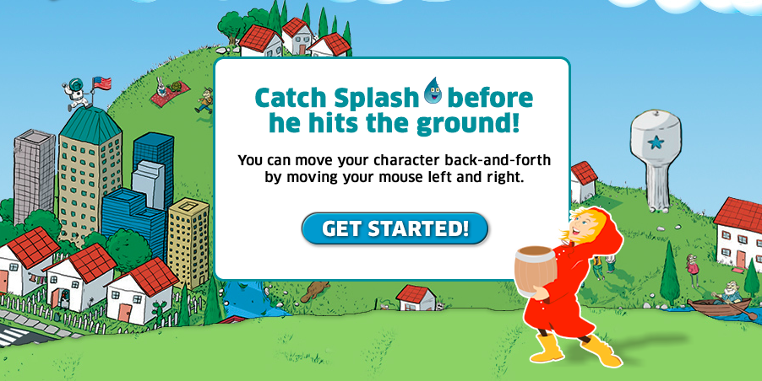
Water is just as important to plants as it is to humans but watering plants can use lots of water. Play Save Splash the Raindrop and consider what we could do to ensure our plants are well-watered, while ensuring we are sustainable beings by managing our water usage and being more environmentally friendly.

Q. What can we do or use to manage our water usage in our vegetable garden?
Hint: we live somewhere that it rains a lot!

- _____________________________________________________________________

_____________________________________________________________________

_____________________________________________________________________

_____________________________________________________________________

_____________________________________________________________________

_____________________________________________________________________

_____________________________________________________________________

_____________________________________________________________________

_____________________________________________________________________

Task 6:
We now need to decide on what fruits and vegetables we can grow in our garden. However, it is important to remember that the fruit and vegetable seeds we plant are ones for the climate we live in.

Q. What fruits or vegetables can you think of that grow in our area and will be useful our school tuck-shop? Remember, we don’t want to grow produce that we will not use.

Hint: Think carefully about the fruits and vegetables you see growing in our area.

- ________________________

- ________________________

- ________________________

- ________________________

- ________________________
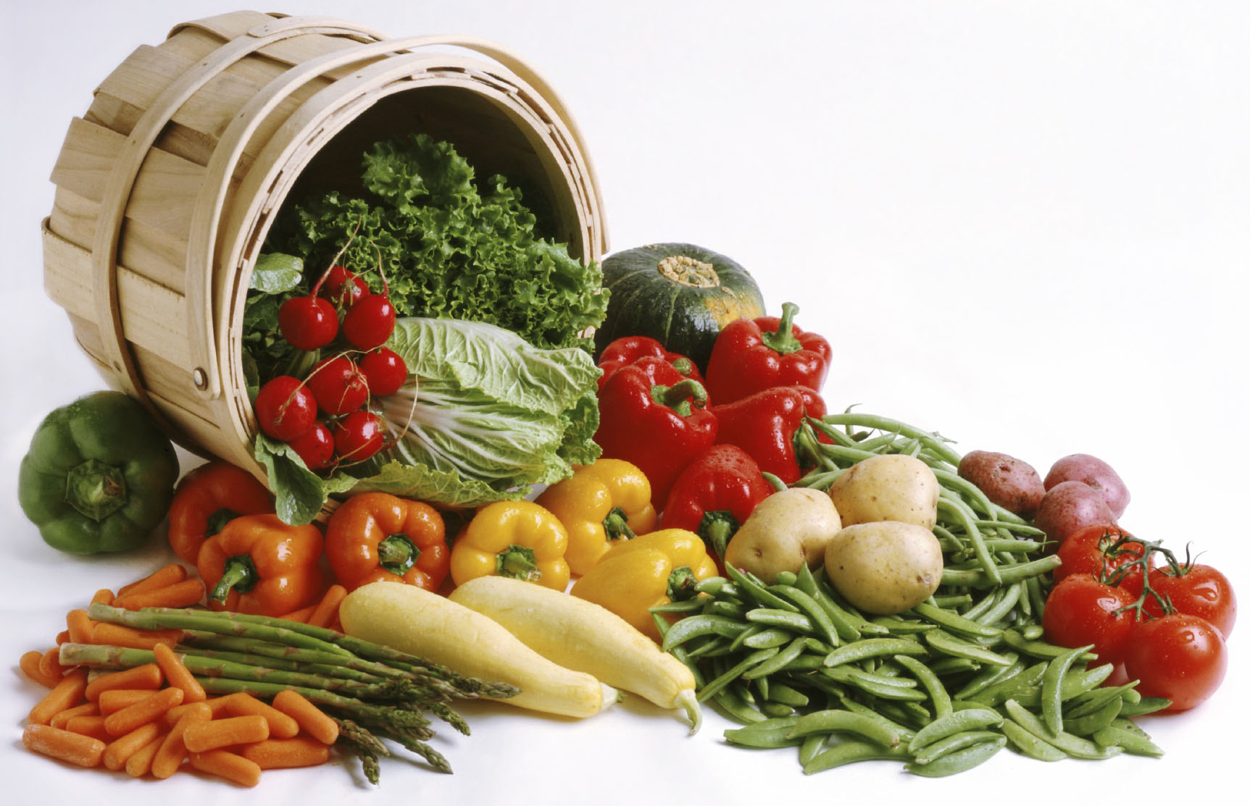
Task 7:
The fruits and vegetables we grow will be mainly used in the tuck-shop where but we might have produce left over after supplying the tuck-shop.

Q. List the different things we could do with the leftover produce? Write down as many ideas as possible. One has been completed for you.

- Give the fruit to students for lunch.

- _____________________________________________________________________

- _____________________________________________________________________

- _____________________________________________________________________

- _____________________________________________________________________

- _____________________________________________________________________

Task 8:
Watch this short video about building compost bins and worm farms to get some ideas about different sustainable technologies we can use to fertilise our vegetable garden.

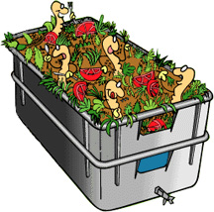

Q. Record two important things you have learnt about worm farms and compost bins while watching the above video. They may be about how to build the worm farm or compost bin, how they work, or what they waste can be used for.

- _____________________________________________________________________

_____________________________________________________________________

- _____________________________________________________________________

_____________________________________________________________________

Task 9:
You must now show your completed work to your teacher who will check that everything has been completed. Once you have done this, you will be swapping your design with another student’s. You will be evaluating their design based on the ideas, processes, and solutions for the vegetable garden. You may express what you like about the design and what you do not like but you need to justify your answers and tell your partner why you do or do not like an aspect of their design.

Q. Write below a review of your partner’s design for the vegetable garden.

A. ___________________________________________________________________________

___________________________________________________________________________

___________________________________________________________________________

___________________________________________________________________________

___________________________________________________________________________

___________________________________________________________________________

___________________________________________________________________________

___________________________________________________________________________

___________________________________________________________________________

___________________________________________________________________________

___________________________________________________________________________

___________________________________________________________________________

___________________________________________________________________________

___________________________________________________________________________

___________________________________________________________________________

___________________________________________________________________________

___________________________________________________________________________

___________________________________________________________________________
Task 10:
If you have completed all of your work, you may have a game of Get Growing to practice your gardening schools before we begin our garden. Click on the picture below to begin.
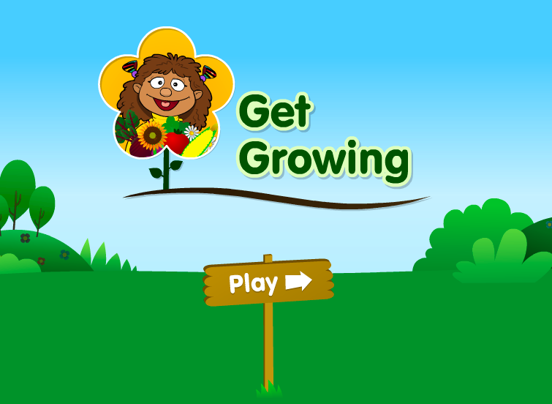
Q. Write down two things that the plants needed in Get Growing to help them grow healthy plants with lots of produce.

- _____________________

- _____________________

