Name: ________________________________

Type whether you would measure the following with metres (m), centimetres (cm) or millimetres. The first one has been done for you to show you how to do the task.
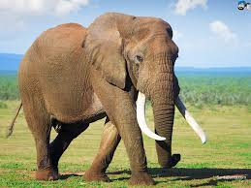 Metres. | 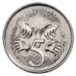  ___________________
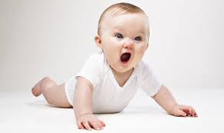____________ | 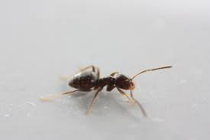 _____________
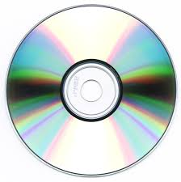_____________ | 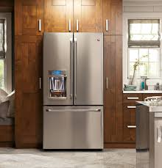____________

Look around the classroom and find an object you would measure with a metre (m), centimetre (cm) and a millimetre (mm). Type the objects you found below:

Metre (m):
Centimetre (cm):
Millimetre (mm):

